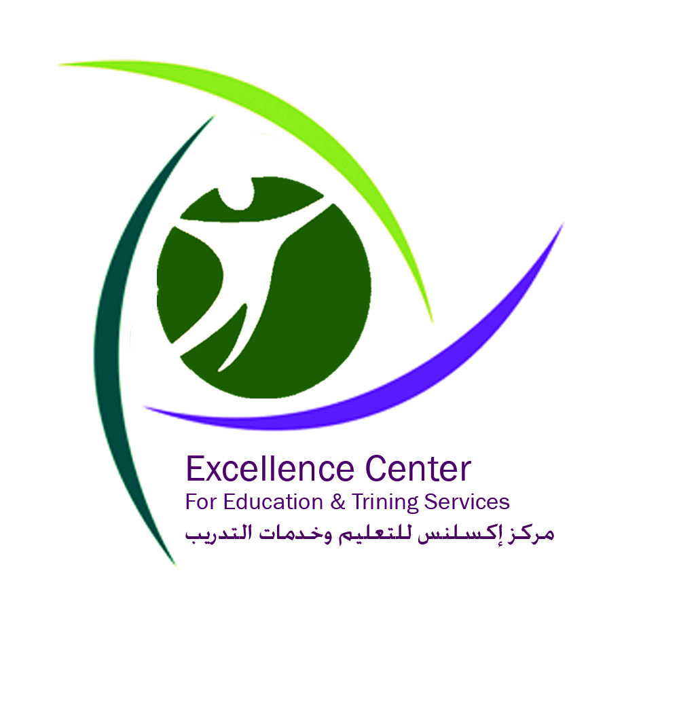
Excellence Center Application
Study Arabic in Palestine Program 2013/2014 and Individual Courses Year Round
Welcome to Excellence Center!
Students at the Excellence Center (EC) have many exciting opportunities when they arrive to Hebron. We are sure you will enjoy your time spent living and studying with us. Students of Arabic spend some of their time staying with a host family and learning Arabic with a Palestinian teacher as well as participating in social and community activities. Students of Arabic have the opportunity to meet Palestinian youth at our center. Furthermore, students have the opportunity to organize workshops for the Palestinian community in the city of Hebron with the facilities of Excellence Center to further engage with the Palestinian culture.
We offer books and teaching materials for all levels. Depending on your level (Beginner Arabic level, Intermediate Arabic level, and Advanced Arabic level) Excellence Center’s staff develops curriculums to meet your level. The study Arabic in Palestine program combines the study of the Arabic language with the living of Palestinian daily life. Students get the opportunity to immerse themselves in the Palestinian culture by staying with a host family, meeting Palestinian youth, visiting different local and educational organizations such as different local actors, media and industry. Excellence Center provides you the opportunity to interact with different people from different educational backgrounds, ages and gender. Furthermore, at Excellence Center we host international interns year around who come from Europe and the US.
You will have the opportunity to meet them as well as engage with the Excellence’s Center Staff. Don’t worry you will not have an empty schedule and you will not feel bored. Students, who are interested in the conflict, will also have the opportunity to form their own opinion or just get an impression of the different aspects of the conflict.
Excellence Center gives students 5 days of vacation a month so that they can travel around Palestine. We like to share meals together at the center, so you will learn how to cock Palestinian food. Additionally, as mentioned, you will have the chance to make friends with our team of native volunteers and staff –creating cultural exchange for life. EC can provide you with contacts to meet University students for peer-to-peer learning at your request.
Excellence Center team will provide you all information regarding travels. An invitation letter will be sent to each participant. At each stage of the application process, a skype call will be organized with the students.
No prior visa is needed for Americans, Canadians, and most Europeans to enter Israel and Palestine. Students must have health insurance before coming to Hebron, as health services will not be provided. Persons of Palestinian origin regardless of their nationality will have to consider travelling through Jordan. Excellence Center staff will assist you in planning your travels and send you necessary information.
Thank you for your interest in applying for the Study Arabic in Palestine program with Excellence Center. Our outstanding team will work to help and provide you a good stay in Palestine.
Personal Information:
First Name:
Middle Name:
Last Name:
Gender:
Home Address:
City:
Country:
Home Telephone:
Mobile:
Email:
Date of Birth:
Nationality:
Religion :

Emergency Contact Information:
Name:
Relationship to Delegate:
City, Country:
Home Telephone:
Mobile:
Email:

Please introduce yourself with regard to your university/ college in which you are currently enrolled, school level, academic major/minor, and current GPA
List all Arabic language courses you have completed; include current courses taught in Arabic. How would you describe your level or command of Arabic?

Country | Duration of Stay | Purposes of Stay

Please share with us your main motivation for studying Arabic in Palestine.

Have you been to Middle East before? If yes, please fill in the table

Where and how did you get information about the study Arabic program at Excellence Center?

- Please attach:
- A recent photo of yourself.
- An Up-to-date resume.

Please submit your application by email 15 days prior to the Arabic Intensive Program in December, March, June and September, and 1 week ahead of time for the individual course which take place year round.
Excellence Center For Education and Training Services
Ein Sara St., Hebron, Palestine
Fax: +970 2 2254792
Email: apply@excellencenter.org

Find us on Facebook
Explore Palestine: https://www.facebook.com/ExplorePalestine
Excellence Center: https://www.facebook.com/ExcellenceCenter
Website: www.excellencenter.org

Thank you very much! We hope to meet you in Palestine!
Excellence Center Team
Hebron-Palestine

